**Trehalose vs Other Sugars for Protein Stability**

Sugars improve the storage stability of dried proteins. Although there are many complex reasons for this stability, there are two main mechanisms: water replacement and vitrification. During drying, proteins lose some of their hydration spheres, resulting in hydrogen bonds forming within proteins that changes their structure.1 The addition of sugars allows hydrogen bonds between protein and water to be replaced by hydrogen bonds between the protein and the hydroxyl groups of sugar molecules. When proteins are incorporated into a sugar matrix in the glassy state, the rate of protein degradation decreases due to lessened molecular mobility of the protein.1

There are two key criteria that a sugar should meet for stabilizing proteins. Firstly, it is important that the sugar stays in the glassy state during storage to avoid crystallization and high molecular mobility of the protein. Thus, sugars with a relatively high glass transition temperature (Tg) are ideal. Secondly, the sugar should have little to no reducing groups because these groups react with amine groups on proteins, starting a cascade of reactions known as the Maillard, or browning, reaction.1

Monosaccharides such as fructose or glucose are not ideal for protein stabilizing because they have a relatively low Tg and have reducing groups. Sucrose (Tg 77 °C) and trehalose (Tg 121 °C) are disaccharides with no reducing groups and higher Tgs, making them ideal for stabilization. Residual moisture after drying or in storage lowers the Tg because water acts as a plasticizer, which may lower the Tg below storage temperature. Oligosaccharides such as insulin or dextran have very high Tgs, so even if residual moisture is present after drying, the Tg is still well above storage temperature. Although higher molecular weight sugars have higher Tgs, steric hindrance and limited flexibility reduce the ability of these sugars to stabilize proteins well. Polysaccharides may be combined with a disaccharide to overcome this challenge.2,3

In a study by Hinrichs *et al*, four different-sized, freeze-dried proteins were used to test the stabilizing ability of different sized sugars.1 Table 1 shows the different proteins, sugars, and their Tg values before and after storage.1 The Tg for all samples was above the storage temperature of 60 °C.

**Table 1: Tg of different sugars and protein formulations (Protein-sugar ration 1:249 (w/w) and water content of placebos after freeze-drying. Figure from reference 1.**

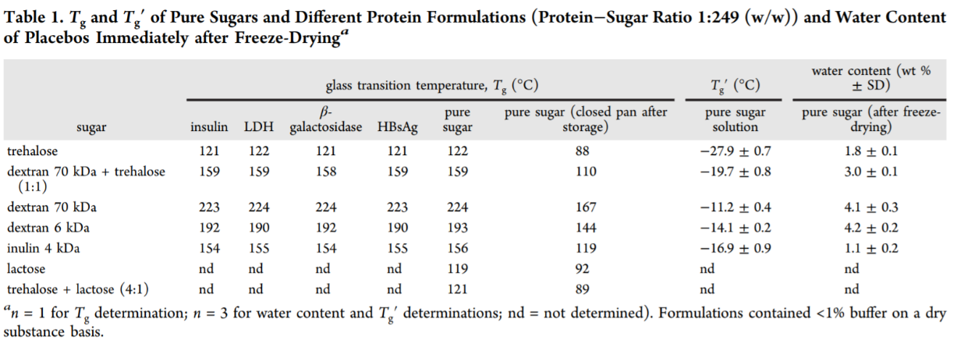

This study also showed that trehalose had the lowest percentage of reducing groups (relative to glucose), at 0.1%.1 Lactose had the highest, at 82.1%, so it is not an ideal disaccharide for retaining protein stability. It was determined LDH had the highest retained activity in trehalose formulations after 28 days of storage at 60 °C. For each of the four proteins tested, trehalose formulations had the lowest rate of protein degradation, except for HBsAg (however, the difference was small).Overall, it was found that proteins freeze-dried in the presence of the smallest sugar (trehalose) were best stabilized during storage, and flexible oligosaccharides stabilize better than rigid ones. The researchers ranked trehalose as the best formulation, with dextran 70 kDa and trehalose (1:1) as second-best for protein stability.1

In another study by Hedoux *et al*, the bioprotective properties of sucrose and trehalose were investigated by *in situ* Raman investigations.4 It was found that the unfolding temperature of the protein secondary structure was lower in trehalose formulations than sucrose (by approximately 5 °C). This result indicates that trehalose has a lower bioprotective effect than sucrose in the presence of residual water because sucrose has a lower affinity for water. However, it was determined that trehalose was more efficient for preserving lysozyme structure during long-term storage. Dielectric spectroscopy showed removal of residual water significantly improves the bioprotective effect of trehalose compared to sucrose. The researchers from this study conclude that trehalose is recommended for protein stability and protection.4

It has been shown that trehalose has a greater water-destructuring effect than sucrose.5 A stronger destructuring effect leads to less crystallizable water which would damage biological materials in cooling. The structure factor of bulk water is more similar to sucrose than trehalose, supporting the idea that trehalose perturbs the network structure of bulk water better than sucrose. The most plausible explanation is that the way water binds to trehalose alters the 3D structure of bulk water more than sucrose.5 The radius of gyration was also found to be larger for trehalose than sucrose. There are few discrepancies in the overall structure of solutions of trehalose and sucrose, however, these differences may explain why trehalose is considered superior to sucrose as a stabilizing agent.

References

1. Tonnis, W. F.; Mensink, M. A.; De Jager, A.; Van Der Voort Maarschalk, K.; Frijlink, H. W.; Hinrichs, W. L. J. Size and Molecular Flexibility of Sugars Determine the Storage Stability of Freeze-Dried Proteins. *Mol. Pharm.* **2015**, *12* (3), 684–694. <https://doi.org/10.1021/mp500423z>.
2. SD, A.; MC, M.; TW, R.; K, M.; A, D.; JF, C. Optimization of Storage Stability of Lyophilized Actin Using Combinations of Disaccharides and Dextran. *J. Pharm. Sci.* **2000**, *89* (2). [https://doi.org/10.1002/(SICI)1520-6017(200002)89:2<199::AID-JPS7>3.0.CO;2-B](https://doi.org/10.1002/(SICI)1520-6017(200002)89:2%3c199::AID-JPS7%3e3.0.CO;2-B).
3. Garzon-Rodriguez, W.; Koval, R. L.; Chongprasert, S.; Krishnan, S.; Randolph, T. W.; Warne, N. W.; Carpenter, J. F. Optimizing Storage Stability of Lyophilized Recombinant Human Interleukin-11 with Disaccharide/Hydroxyethyl Starch Mixtures. *J. Pharm. Sci.* **2004**, *93* (3), 684–696. <https://doi.org/10.1002/jps.10587>.
4. Starciuc, T.; Malfait, B.; Danede, F.; Paccou, L.; Guinet, Y.; Correia, N. T.; Hedoux, A. Trehalose or Sucrose: Which of the Two Should Be Used for Stabilizing Proteins in the Solid State? A Dilemma Investigated by In Situ Micro-Raman and Dielectric Relaxation Spectroscopies During and After Freeze-Drying. *J. Pharm. Sci.* **2020**, *109* (1), 496–504. <https://doi.org/10.1016/j.xphs.2019.10.055>.
5. Olsson, C.; Swenson, J. Structural Comparison between Sucrose and Trehalose in Aqueous Solution. *J. Phys. Chem. B* **2020**, *124* (15), 3074–3082. <https://doi.org/10.1021/acs.jpcb.9b09701>.